Introduction to Rave Reports - Part I: Code Based Reports
By: Leonel Togniolli
Abstract: This is a introduction to Rave Reports. Part I describes how to work with Code Base reports. - by Leonel Togniolli

Introduction to Rave Reports - Part I: Code Based Reports
Delphi 7 has included Rave Reports as the default reporting solution, replacing Quick Reports. Since they work in very different paradigms, many people were confused by the new environment. This is intended as an introduction for people who haven't worked with Rave yet, and would like to start.
Delphi 7 ships with Rave Reports 5.0.8. If you haven't already, download the update from the registered users page, since it fixes some important problems.
You can develop reports with Rave using two different ways: Code Based or with the Visual Designer. This document describes how to work with the code based engine. Part II will describe the Visual Designer.

Code Based Reports
With Code Based, you write reports using plain Delphi code. That provides a very flexible way displaying any kind of data, allowing any kind of complex layouts.
To write a code based report, just drop a TRvSystem component on the form and write the report on the OnPrint event handler. Sender is the report you are creating, and can be typecasted to TBaseReport. It contains all the methods you need to output information to that particular report.

Simple Code Base Report
Here's a simple report using the code based mechanism:

procedure TFormMain.RvSystemPrint(Sender: TObject);
begin
with Sender as TBaseReport do
begin
SetFont('Arial', 15);
GotoXY(1,1);
Print('Welcome to Code Based Reporting in Rave');
end;
end;
To execute this report, call RvSystem.Execute method.
So, what does that simple code do? First, it calls SetFont to select the font and size of the text that will be printed from that point on. Then it positions the cursor on the coordinates (1,1). These coordinates are expressed using the units set in the SystemPrinter.Units property of the RvSystem object, and it defaults to Inches. You can set it to unUser and set a number relative to Inches in the SystemPrinter.UnitsFactor property. For example, if UnitsFactor was set to 0.5 then 1 unit would correspond to half an inch. Finally, the code calls the Print method to output the text. Here's the output:
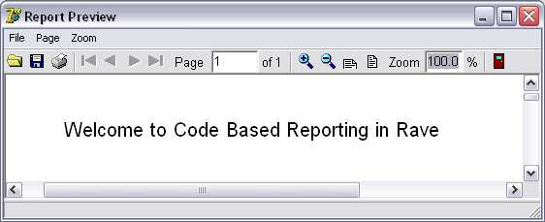

Tabular Code Based Report
Here's another example. It displays a list of the folders in the root of the current drive, along with a recursive count of number of files and folder, and total size of the files included in each folder.

procedure TFormMain.PrintTabularReport(Report: TBaseReport);
var
FolderList : TStringList;
i : Integer;
NumFiles : Cardinal;
NumFolders : Cardinal;
SizeFiles : Cardinal;
Root : string;
begin
with Report do
begin
SetFont('Arial', 15);
NewLine;
PrintCenter('List of Folders in the Drive Root', 4);
NewLine;
NewLine;
ClearTabs;
SetTab(0.2, pjLeft, 1.7, 0, 0, 0);
SetTab(1.7, pjRight, 3.1, 0, 0, 0);
SetTab(3.1, pjRight, 3.5, 0, 0, 0);
SetTab(3.5, pjRight, 4.5, 0, 0, 0);
SetFont('Arial', 10);
Bold := True;
PrintTab('Folder Name');
PrintTab('Number of Files');
PrintTab('Number of Folders');
PrintTab('Size of Files');
Bold := False;
NewLine;
FolderList := TStringList.Create;
try
Root := IncludeTrailingPathDelimiter(ExtractFileDrive(ParamStr(0)));
EnumFolders(FolderList, Root);
for i := 0 to FolderList.Count - 1 do
begin
PrintTab(FolderList[i]);
GetFolderInfo(IncludeTrailingPathDelimiter(Root+FolderList[i]),
NumFiles, NumFolders, SizeFiles);
PrintTab(Format('%u',[NumFiles]));
PrintTab(Format('%u',[NumFolders]));
PrintTab(Format('%u bytes',[SizeFiles]));
NewLine;
end;
finally
FolderList.Free;
end;
end;
end;
Notice that a different approach has been taken: instead of specifying the coordinates of each text output, the printing was done using Lines and Columns as references. The line heigh depends on the size of the current font: each unit represents 1/72nds of an inch, so each line printed with a size 10 font will have, aproximatelly, a height of 0.138 inches. Lines are advanced after calls to PrintLn or NewLine. Colums are defined using calls to the SetTabs method, and the PrintTab method will print the text in the current column and advance to the next one. Here's the output:
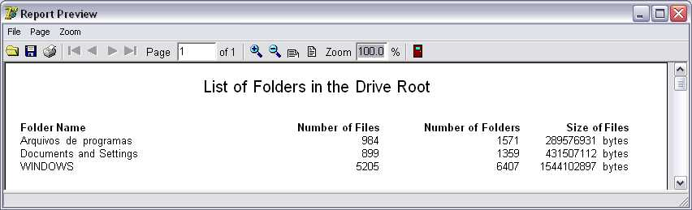
You can find the full source, including the implementation of EnumFolders and GetFolderInfo, on CodeCentral.

Graphical Code Based Report
You can include shapes and images in your code based report, along with the text. The following example demonstrates that:

procedure TFormMain.PrintGraphicsReport(Report: TBaseReport);
var
Bitmap : TBitmap;
begin
with Report do
begin
Canvas.Brush.Color := clGray;
Rectangle(0.3, 0.3, 4.7, 3.3);
SetFont('Arial', 15);
FontColor := clRed;
PrintXY(0.5,0.5, 'Just look at all the graphics!');
Bitmap := TBitmap.Create;
try
Bitmap.LoadFromFile('delphi.bmp');
PrintBitmap(3.5,0.3,1,1, Bitmap);
PrintBitmap(1,2,3,3, Bitmap);
Canvas.Pen.Color := clBlue;
Canvas.Brush.Bitmap := Bitmap;
Ellipse(5,0.3,6,3.3);
Ellipse(2,1,4,1.9);
finally
Bitmap.Free;
end;
Canvas.Pen.Color := clBlack;
Canvas.Brush.Style := bsSolid;
Canvas.Brush.Color := clYellow;
Pie(0.7,0.7,1.7,1.7,1,1,1,2);
Canvas.Brush.Color := clGreen;
Pie(0.7,0.7,1.7,1.7,1,2,1,1);
end;
end;
In this example the methods Rectangle, Ellipse and Pie have been used draw shapes with different fills. Bitmaps were outputted using PrintBitmap and as the brush of the ellipses. Here's the output:
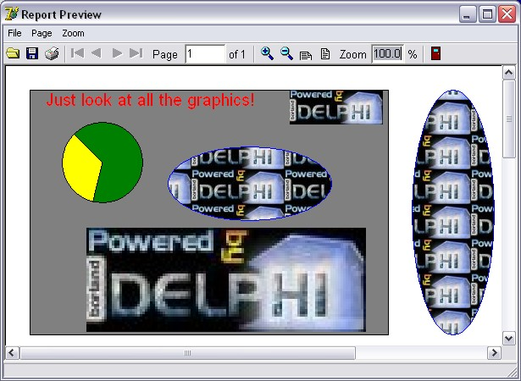
A sample application, containing full source code for those three examples can be found at CodeCentral.

Conclusion
As you can see, code based reporting offers a great flexibility and control of the layout you want, but require some work to implement them. In Part II we will see how the Visual Designer can be used to build powerful reports in a very easy way.

Introduction to Rave Reports - Part II: Visual Designer
By: Leonel Togniolli
Abstract: This is a introduction to Rave Reports. Part II describes how to work with the Visual Designer - by Leonel Togniolli

Introduction to Rave Reports - Part II: Visual Designer
In the Part I of this document, you have seen how the Code Based engine of Rave Reports works. Now we are going to explore the Visual Designer.

The Visual Designer
If you are used to work with Quick Reports, the default reporting engine included in the previous versions of Delphi, you created your reports using Delphi's own form designer, and they were save in the DFM, included as resources in your executable. Rave works a bit diferently in this aspect: it has it's own report designer, and saves the report using it's own file format. This has some advantages, including the fact that your reports can be made "standalone", and be used or updated independently of your application, or even made available in a Intranet or in the Internet, using Nevrona's Rave Report Server. Of course, you can still have it saved in a form's DFM.
To get started with the Rave Visual Designer, drop a TRvProject in a form. This will be the link from your application to the reports you are developing. If you want, you can add a TRvSystem and link your RvProject to it, through it's Engine property. The RvSystem is the object responsible for the general configuration of the reports: the printer that is going to be used, the margins, the number of pages, and so on. To start a new project, double click the RvProject you added to the form, or select "Rave Visual Designer..." from its context menu. This is the interface that you will be working on:
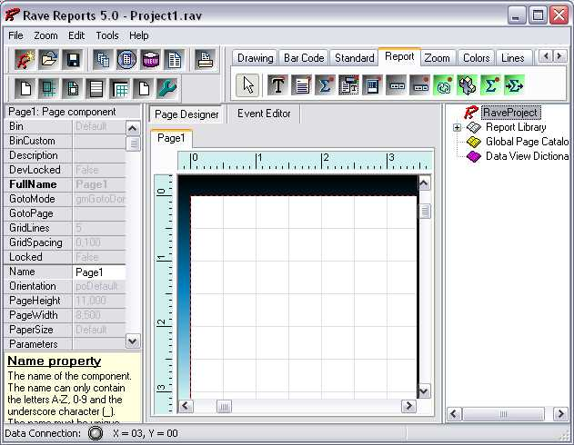
The interface is simple, and you might be familiar with some parts of it from Delphi's IDE. On the top there's the menu, the toolbar, and the component pallete that contain the components that will be used in the reports. In the left there's the Object Inpector, which will be used to adjust the properties of the components of the report. In the middle there's the Page Designer or the Event Editor, and in the left there's the very usefull Project Treeview. For a quick overview of the components in the pallete, you can go to Nevrona's Visual Designer page.
A Rave Project File can have one or more reports. That way you can keep common items between them in a single location, called Global Pages. If you expand the Report Library node of the Project Treeview, you can see that right now you are working on Report1. Clicking on it, its properties will show on the Inspector. Let's change it's name and call it SimpleReport. Next, go to the Standard tab on the Component Pallete, and pick a Text component and add it to the page. Change its text property, and adjust its size and position. Here's how mine looked like:
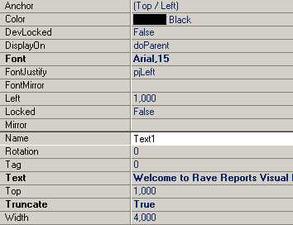
As you can see, the properties that were changed from the default values are shown in bold. In this case, I changed the Font, Text and Truncate properties. By default it does not highlight Name, Pos and Size changes. If you'd like to see them, right click the Inspector and uncheck "Exclude Name, Size and Pos changes" in the context menu.
You might have also noticed that Rave does not have an auto size property. You can use the Truncate property to have that effect: if truncate is false, the design time size will have no effect.
You can see the result of this simple report right on the designer: Press F9 or use File/Execute Report to run it. Now let's do it in our application. Save your project and return to Delphi. Change to ProjectFile property of RvProject to point to the file you just saved. To run the report, add a call to the Execute method of the RvProject object in a button click, for example.
RvProject.Execute will only work for now because we only have one report in this project. If we had multiple reports, we'd have to call SelectReport to choose one before calling Execute, or calling ExecuteReport directly.
Here's the output:
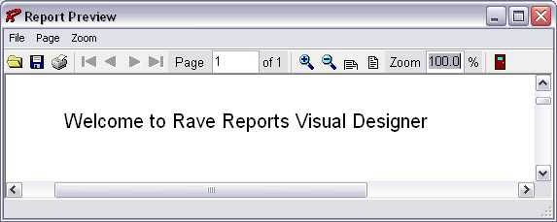
Tip: If you Close and Open your project before executing, you won't need to to recompile your application or restart it to see the changes you just made in the designer.

Interacting with the Project
If you worked with Quick Reports, you might be used to manipulating the objects in runtime, changing their Position, Text and Visibility. After all, they were just TObjects! While this is possible with Rave, and I'll cover it in a later article, it's a little harder than it was with QR. But don't worry, Rave provides a different answer to this kind of problems.

Parameters
If you can use parameters in your reports. They can be defined using the parameters property of either the Project, a Report or a Page. Parameters can be defined in either of these places, they are just in multiple places for easier access.
You can only select the Project and a Report through the Project Treeview. A page, however, can be selected using the Project Treeview or clicking on it's title above the page designer.
Among other uses, you can print parameters. So, for instance, if the title of your report can be user-defined, you could pass it from your application into the report as a parameter.
Let's add a new report to this project to see how parameters work. To do that, click the fourth button on the toolbar or choose File/New Report. Call it ParametrizedReport, changing its name through the object inspector. This report is going to be very similar to the first one, except the text is going to be user-defined.
Now we need to define the parameter that is going to be printed. To do that, still having the report as the selected object, open the property editor the the parameters property. There should be listed all parameters of this report, each on a separate line. Add a parameter called Name, like this:
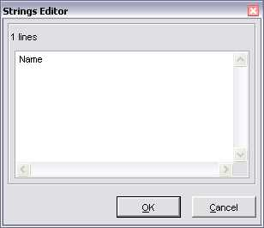
Parameters can be printed using a DataText component, available in the Report tab of the component pallete. Add a DataText to the page, and open the property editor of the DataField property. There you can choose which field is going to be printed, when working with DataAware reports (which will be covered on Part III of these series). You can also choose Project Variables, Parameters and Post-Initialize Variables from there.
So choose the parameter added previously from the Parameters drop-down combo and press the Insert Parameter button. The data text expression is now Param.Name (we are going to change that a little later). Press OK and try to execute the report, as before. Nothing is printed, since the parameter has not been set.
We need to set this parameter before printing. Don't forget to save your changes, and return to Delphi, adding a call to SelectReport before Execute, so we can see the right report. Before executing, though, we need to set the parameter we added. That is made using RvProject's SetParam method. This is how my code looks like right now:
procedure TFormMain.btnExecuteClick(Sender: TObject);
begin
RvProject.Open;
RvProject.SelectReport('ParametrizedReport',False);
RvProject.SetParam('Name','Leonel');
RvProject.Execute;
RvProject.Close;
end;
Now, when we execute the report, we are going to see the string we set as a parameter printed.
Tip: You can use RvProject.GetReportList to get a list of avaible projects, and add them to a ComboBox, or a RadioGroup, for example. That makes selecting the report easier.
But this is too simple. Let's change the expression that is going to be printed. Return to Rave Designer and open the property editor for the DataText we added. You can add any text you want, combining text, fields, parameters and variables. I changed it to this:
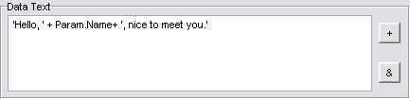
Here's the result:
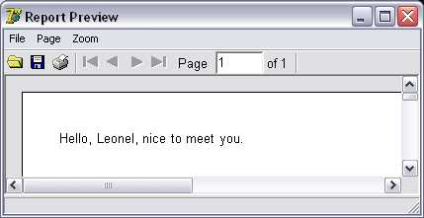

Post-Initialize Variables
Post-Initialize Variables, or simply PI Vars, are variables whose value is only known after the report has already been printed. It may sound strange, at first, but think about the number of pages of a report, for example. We can only know it's value after the report is ready. Actually TotalPages is a report variable that acts like a PI var, and can easily be printed using DataTexts as we did with Parameters.

Global Pages
When you have parts of reports that are common to two or more reports, you can put these in a global page. Let's supose we have a header with our company name, the date and time that report is being printed, the current page and the number of pages of that report. We want that header to be in every report. How can we do it?
First, add a global page to the project, using File/New Global Page, or the Toolbar shortcut. In that page, add a section component, available in the standard tab of the component pallete.
Sections are logical groupings of components. they can be used to group component so they can be easily moved around the report, or as containers for Mirrors, as we are doing right now.
Inside that section we add what we want to be printed. In this case, a few DataTexts. My header looks like this:
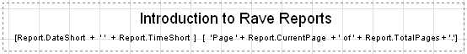
Hint: Instead of changing the font property of several components to the same font, link them to a FontMaster component, available in the standard tab, and set the font on it. That way is easier to change the font in the future, in case it's needed.
Now add another section to the Page1 of SimpleReport. Set its Mirror property to GlobalPage1.Section1. You will see a copy of the header you created in the global page. Do the same thing to ParametrizedReport. Now both reports share the same header. Here how it looks like for me:
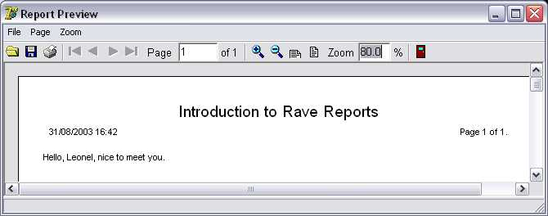

Conditional Printing
Sometimes we need to print certain parts of a reporting depending of some conditions. Rave has a very powerful way of dealing with this. We can conditionally mirror sections depending on field values or parameters. Let's create a new Report, calling it a ConditionalReport.
Let's pretend that this new report is a trick one. The user can choose the header that is going to be printed, from two different kinds of headers. He can also choose for the report to be printed without a header. We are going to use a parameter to tell the report what kind of header is going to be printed, and a DataMirrorSection to select the proper header at runtime.
First, add a parameter to this new report called HeaderKind. Let's assume that it will have the values H0 (for no header), H1 (for the first header), H2 (for the second kind of header). Now add a new section to the global page (you can reach it through the Project Treeview), with the second kind of header layout. I created a header similar to the first one, changing the font title and adding a border around the values. It looks like this:
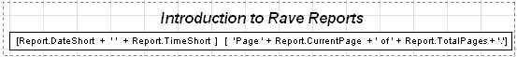
Now return to the Page1 of ConditionalReport, and add a DataMirrorSection, available at the Report tab of the component pallete. Go to its DataField property editor, and set Param.HeaderKind as the expression. Now go to the DataMirrors property editor, and add two Data Mirrors: if the value is H1, it should point to the first header, H2, to the second. Since H0 does not match any mirrors, nothing will be printed. It should look like this:
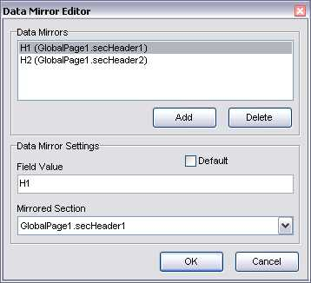
Notice that I gave more meaningful names to each of the sections earlier.
Hint: You can use the OnMirrorValue event of the DataMirrorSection to work on ranges of values.
Now return to Delphi and add the code to set the parameter according to the user's choice. I added a ComboBox with the options and my code looks like this:
procedure TFormMain.btnExecuteClick(Sender: TObject);
begin
RvProject.Open;
RvProject.SelectReport(cmbReports.Text,False);
case cmbReports.ItemIndex of
1: RvProject.SetParam('Name',edName.Text);
2: RvProject.SetParam('HeaderKind',Format('H%d',[cmbHeaderKind.ItemIndex]));
end;
RvProject.Execute;
RvProject.Close;
end;
Now the proper header will be printed according to the user's choice.

Embedding the Project in the Executable
When you deploy your application, you must include you project file. You can have it as a separated file, so you can update it in a easier way, only shipping a new one, without recompiling your application, or include it in your executable. It's easy to do that: open the property editor for the StoreRAV property of RvProject. There you can press Load to include the file in the DFM, Save to extract a previously saved file, and Clear to remove an embedded file. When there's a file loaded in this property, you don't need to ship the project file separately.

Conclusions
We've learned how to work on the Visual Designer, and seen a few tricks that allow some flexible reports. You can find a project containing the sample reports developed here on CodeCentral. On Part III we are going to learn how to create DataAware reports, and operate with bands.

Introduction to Rave Reports - Part III: Data Aware Reports
By: Leonel Togniolli
Abstract: This is a introduction to Rave Reports. Part III describes how to create Data Aware Reports using Driver Data Views - by Leonel Togniolli

Introduction to Rave Reports - Part III: Data Aware Reports
In the previous articles, I have shown how do the Code Based engine and the Visual Designer work. In this document, I'm going to explore the Data-Aware capabilities of Rave Reports.

The Database Connection
There are two ways to access data from inside a report: you can share the same connection established by your application, fetching records from Datasets that exists in your Forms or Datamodules, or you can configure a new connection on the report, allowing it to be independent of a particular application. For the first method you would use a Direct Data View, and a Driver Data View for the second. Data View is the analog of a DataSource/DataSet combination inside the report.
If you intend to deploy your application using Nevrona's Rave Report Server, you should use Driver Data Views.

The Driver Data View
Let's create a simple database report using a Driver Data View. Start the Rave Visual Designer, and start a new project. We need to define the database connection. To do this, choose File/New Database Object, or press the sixth button in the toolbar (the purple cube). The Data Connections window will appear:
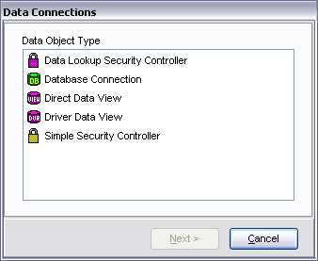
Choose Database Connection, and you will be asked which Data Link you are going to be using. There is a folder called DataLinks where Rave has been installed, containing some files with the .rvd extensions, responsible from the connection mechanism. By default, you can choose between BDE, DbExpress and ADO. I'll be using BDE for this example. Choose BDE, press Finish, and the Database Connection Parameters window will show up. Every Data Link has a different set of connection parameters available, similar to those available in the Delphi IDE. For now, just set Alias to DbDemos and press OK. Notice that a Database object has been added to the Project Treeview, under Data View Dictionary:
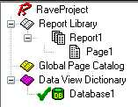
Notice that the settings you configured in the Database Connection Parameters, after the wizard, including username and password, if aplicable, were saved in the AuthDesign property of the Database component. In the AuthRun property you can use different settings to be used at runtime, when your report has been deployed.
We are going to create now the Driver Data View. Click on New Data Object, then choose Driver Data View. You should now choose the Database Connection that is going to be used by this Data View: choose the Database created in the previous step. A Query Avanced Designer will show up. Drag and Drop the table customer.db from the table list to the Layout window. It should look like this:
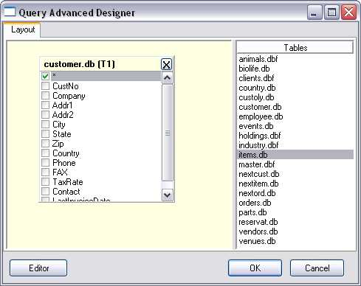
If you have more than one table, you should drag and drop fields that should be joined between tables. If you press the Editor button you can check the generated SQL, or type-in a more complex query. Let's keep the simple Customer Listing for now. Press OK and a DriverDataView will be added to the Project Treeview, below the Database components, having the selected fields as subitems:
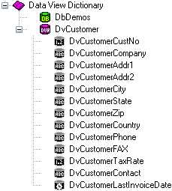
Notice that I renamed the Database Connection and the Data Viewto more appropriate names. It's in the Treeview where properties of the fields should be set, like the Display Label (FullName property), and the DisplayFormat.

Regions and Bands
Report components that should be printed in a fixed position in every page, like fixed headers and footers can be put directly in page. Components whose position will be dependent of previously printed items, should be put in bands. DataBands will be printed once for every record in the linked DataView, while regular Bands will only be printed once, regardless of how many records have been selected. Both can contain Data-Aware components (like DataText), or regular components (like Text).
Bands should be put inside Regions. Regions delimitate the width of the bands, and the maximum height that bands can use before starting a new page. One page can have many Regions, and one Region can contain many Bands.
Add a Region to the Page covering its whole area. Inside the region add a Band, to be used as the report header, a DataBand, to print the customer information, and another Band, the report footer.
If you wish to change the ordering of existing bands in a report, use the Move Forward and Move Behind buttons in the Aligment Toolbar.
Rename the bands to more meaningful names (I used Header, CustomerData and Footer). Set the DataView property of CustomerData to DvCustomer, and set CustomerData as the ControllerBand of the Header and Footer bands. You should also run the Band Style Editor, from the Object Inspector, and set the Print Location of those two bands to Body Header and Body Footer, respectively. You can have an idea on how the report is going to be printed observing the Band Display as you change the settings. It shows iterating bands repeated three times, and other bands only once:
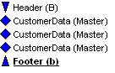
We also want the Header to be printed in other pages in case the listing spans more than one page: check the New Page option in the Print Occurrence groupbox, in that same dialog.
The Footer band will only print when DvCustomers has reached its end. If you want it printed in every page, regardless of that, just put the components directly on the page, below the region, and not in a Band.
In the editor, you can quickly identify the relationship between bands, their styles and their print occurrences:
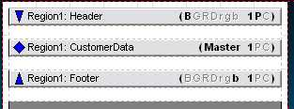

Adding Fields
It's not hard to add fields to a report. You can Ctrl+Drag the fields from the DataView, in the Project Treeview, to add DataText components to the report, and Alt+Drag them to add Text components containing the Fullname property. This allows you to quickly create the layout of the report. Now add some fields to CustomerData and their title to the Header. I added CustNo, Company, Phone, TaxRate and LastInvoiceDate.
Don't forget that you can use the tools on the Alignment Toolbar to align the components, even if they are in different bands.
I added a title to the Header band and a simple text to the Footer band, indicating that the listing has ended. Later on the series we are going to see how to use the CalcOp and CalcTotal components to be able to add totals, averages and other calculated values to the Footer.

Adding the Report to Your Project
To add this report to your project you should use use the same approach as seen in Part II: just use a RvProject in a Form or DataModule, link it to the report file, and call it's Execute method. But there is one gotcha when using Driver Data Views: your application must load the apropriate driver. To do that, just add the unit RvDLBDE to your uses clause, if using BDE, RvDLDBX if using DbExpress, or RvDLADO if using ADO.

Conclusions
This article has shown how to develop simple DataAware reports. You can find a project containing the report developed here on CodeCentral. Part IV will demonstrate the use of Direct Data View, show how to make Master/Detail reports, and how to calculate values to display totals and calculated fields.

Introduction to Rave Reports - Part IV: More Data Aware Reports
By: Leonel Togniolli
Abstract: This is a introduction to Rave Reports. Part IV shows how to create Master/Detail reports using Direct Data Views - by Leonel Togniolli

Introduction to Rave Reports - Part IV: More Data Aware Reports
In Part III we have explored the data aware capabilities of Rave Reports, using the Driver Data View. On Part IV we are going to learn how to use Direct Data Views, the creation of Master/Detail reports, and the use of CalcOP and CalcTotal components to display calculated values and totals.

The Direct Data View
The Direct Data View allows you share the database connection established by your application, fetching data directly from the DataSets in your application. You can link them to any TDataSet descendant, and, with some code, you can even fetch data from custom DataStructures, like arrays of records or TStringLists. Apart from that, it behaves in the way as the Driver Data View we explored on Part III.

Using DataSet Connections
Let's create a master detail report using Direct Data Views. Create a new application, and set up a connection with your database using your favorite Db Framework. I'll still be using BDE, for demonstration purposes. Add two tables (or queries, as you prefer), selecting data from the orders and items tables. For each DataSet, add a corresponding TRvDataSetConnection, available in the Rave tab, in the pallete. Set the property DataSet of each DataSetConnection to the corresponding component, and give them meaningful names (I called them dscItems and dscOrders).
The name is important: it is the your application link to the report. You won't be able to have two DataSet connections, even in different reports, with the same name, or you might run into trouble if someone tries to run both reports concurrently.
After the DataSets are set up, return to the Rave Reports designer. Choose New Data Connection, and you should see the DataSet Connections you added to your form in the Delphi designer:
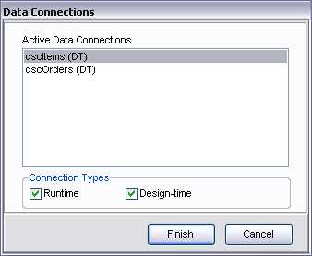
Select dscItems to create the first DataView, then repeat the process to create the DataView for dscOrders. You should now see the fields in the Project Treeview, under the newly created DataViews:
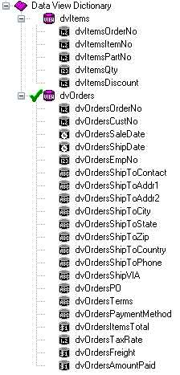
Don't forget to rename the DataViews to better names than DataView1 and DataView2.

Creating the Bands
After the DataViews have been created, we should set up the bands. Create a Region consisting of the whole page area, and add one band (Header), two DataBands (Master and Detail), and another Band (Footer). Set the ControllerBand property of Header, Detail and Footer to Master. Using the BandStyle property editor, set the style of the Header band to Body Header (B), the style of the Detail band to Detail (D), and the Footer band to Body Footer (b). Notice how the Band Display gives a nice preview of how the bands are going to printed:
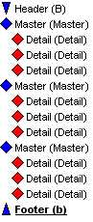
You also need to link the DataView property of the Master band to dvOrders, and the Detail band to dvItems. To create the Master/Detail relashionship, set the MasterDataView property of the Detail band to dvOrders, and both the MasterKey and DetailKey properties to the field OrderNo.

The FontMaster Component
You proably want similar items (all the items in the Detail Band, for example), to print with the same font. Instead of setting each Font property individually, you can you a FontMaster. Add a FontMaster component to the page and set its Font propert to Times New Roman, 10. In the next step, when adding the Text and DataText components, set their FontMirror property to the FontMaster. Now, if you ever change your mind about the font that is going to be used in this report, you don't need to change it in every component, just change it in the FontMaster and it will be reflect in every other component that is linked to it. You can have as much FontMasters in one report as you need.
The FontMaster is a Non-Visual component, meaning it won't show in the Design Area. If you need to reselect it, you will have to do it through the Project TreeView.

Adding the DataTexts
Now its just a matter of adding Text and DataText components to the bands. Don't forget you can drag-and-drop (while pressing the ctrl and alt keys) from the Project Treeview to create them. I added OrderNo, SaleDate, Terms, PaymentMethod, AmountPaid and Freight to the Master band, and ItemNo, PartNo, Qty and Discount to the Detail band. Don't forget that the DisplayFormat of float fields is set in the fields themselves, in the Project Treeview, and not in the DataText components.

Adding Totals and Calculated Fields
You can make calculations and aggregated values using the CalcOP and CalcTotal components, available on the Report tab. The result of these calculations can be outputted to parameters, PI Vars, or used as intermediate result for other calculations. We are going to output them to parameters, so select your report in the Project Treeview and add two parameters, called AmountPaidTotal and FreightTotal:
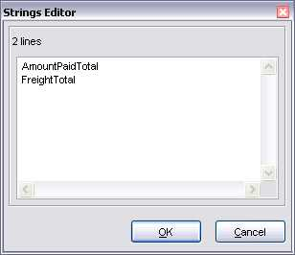
Now add two CalcTotal components to your the Footer band, and set their Controller property to the Master band, their DataView property to dvOrders, the DataField to AmountPaid and Freight, and the DestParam to the params you created earlier, AmountPaidTotal and FreightTotal. It's also in the CalcTotal component where you define the DisplayFormat of the value printed.
Note that the Calc components are evaluated in the order they appear in the Project Treeview. If a CalcOp result is going to printed by a DataText component, make sure it appears in the Treeview before it. You can use the buttons Move Forward and Move Behind from the Alignment Toolbar to change their order.
You can now add in the Footer Band two DataText components to print those variables. Notice that is has summed the values, and you can define through the CalcType property of the the CalcTotal components the operation you would like to perform.
The sample data included in the DbDemos does not have a value for Freight in any of the records. Feel free to edit a few records to see them added up.
Now let's suppose we need to sum both totals, and display them in the footer band. Add a new parameter called Total to the report and a CalcOp component below the CalcTotal components, in the Footer band, and set the Src1DataField to Param.AmountPaidTotal, and Scr2DataField to Param.FreightTotal. Set the DestParam property to Total, and the DisplayFormat of the value. Add a DataText to print this value.

Finishing Up
To add the report to your project, just do the same as was done in the previous reports: just link it in a RvProject and call the execute method. You might want to filter the DataSet based on user input, but that's the same way as you always done before.

Conclusions
We have seen how to create DataAware reports using Direct Data Views, how to set up master/detail relationships, and how to use Calc components. You can find a project containing the report developed here on CodeCentral. Part V will demonstrate the use of Custom Connections and some other tricks.

